Solution for the Module 10 Assignment
The graded problems in Module 10 involve schema conversion. You should label the problems in a document so that the grader can easily match your work to the specified problems. Problems 1 to 4 involve the ERD in Figure 1.
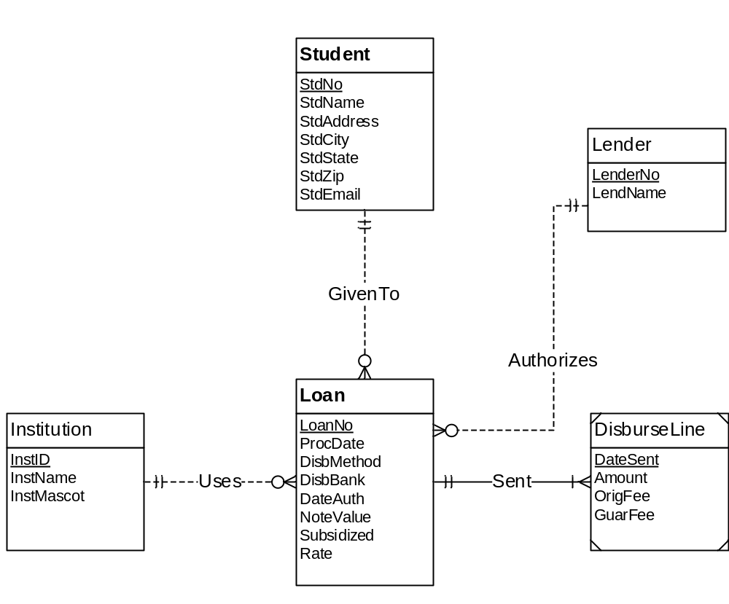
Figure 1: ERD for Problem 3
- For the ERD in Figure 1, you should indicate the applications of the entity type rule. For each entity type rule application, you should identify the table name, primary key, and other columns. You do not need to write CREATE TABLE statements.
Answer
Entity rule to convert Student, Lender, Loan, Institution, and DisburseLine into tables with primary keys and other columns for each table.
Student (StdNo, StdName, StdEmail, StdAddress, StdCity, StdState, StdZip )

Lender (LenderNo, LenderName)
Institution (InstNo, InstName, InstMascot)
Loan (LoanNo, ProcDate, DisbMethod, DisbBank, DateAuth, NoteValue, Subsidized, Rate)

DisburseLine (DateSent, OrigFee, GuarFee)

- For the ERD in Figure 1, you should indicate applications of the 1-M relationship rule. For each 1-M relationship rule application, you should indicate the changes to the tables you listed in problem 1 including foreign key columns and NOT NULL constraints for foreign keys if necessary.
Answer
1-M relationship rule to convert GivenTo (StdNo FK in Loan table), Uses (InstNo FK in Loan table), Sent (LoanNo FK in DisburseLin table), and Authorizes (LenderNo FK in Loan table) relationships. NOT NULL constraints should be defined for each foreign key.
Loan (LoanNo, StdNo, InstNo, LenderNo, ProcDate, DisbMethod, DisbBank, DateAuth, NoteValue, Subsidized, Rate)
FOREIGN KEY (StdNo) REFERENCES Student
FOREIGN KEY (LenderNo) REFERENCES Lender
FOREIGN KEY (InstNo) REFERENCES Institution
StdNo NOT NULL
LenderNo NOT NULL
InstNo NOT NULL

DisburseLine (LoanNo, DateSent, OrigFee, GuarFee)
FOREIGN KEY (LoanNo) REFERENCES Loan
LoanNo NOT NULL

- For the ERD in Figure 1, you should indicate applications of the M-N relationship rule. For each M-N relationship rule application, you should list the table name, primary key, and other columns.
Answer
No application of the M-N rule
- For the ERD in Figure 1, you should indicate applications of the identifying relationship rule. For each identifying relationship rule application, you should indicate the changes to the tables you listed in problem 2.
Answer
One application of the identifying relationship rule to add LoanNo as part of the PK of DisburseLine. The primary key of DisburseLine is a combination of LoanNo and DateSent. The NOT NULL constraint for LoanNo is no longer needed because LoanNo is part of the primary key.
DisburseLine(LoanNo, DateSent, OrigFee, GuarFee)
FOREIGN KEY (LoanNo) REFERENCES Loan

- Convert the ERD shown in Figure 2 into tables. List the conversion rules used and table design. For each table, you should list the primary key, foreign keys, other columns, and NOT NULL constraints for foreign keys if necessary. You do not need to write CREATE TABLE statements.
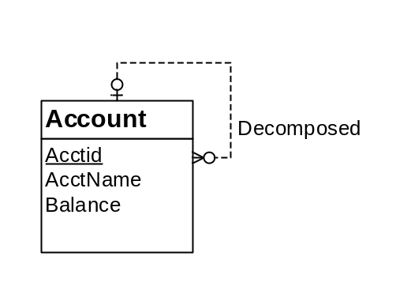
Figure 2: ERD for Conversion Problem 5
Answer
One application of the entity type rule to define the Account table and one application of the 1-M relationship rule to add a foreign key (ParentAcctId) in the Account table. The foreign key column name should be made by the designer. ParentAcctId can accept null values as the minimum cardinality is 0.
Account(AccountId, AcctName, Balance, ParentAcctId)
FOREIGN KEY (ParentAcctId) REFERENCES Account

- Convert the ERD shown in Figure 3 into tables. List the conversion rules used and table design. For each table, you should list the primary key, foreign keys, other columns, and NOT NULL constraints for foreign keys if necessary. You do not need to write CREATE TABLE statements.
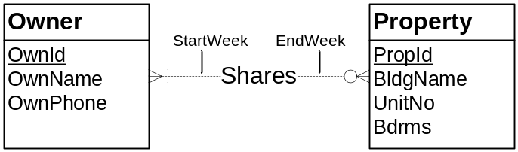
Figure 3: ERD for Conversion Problem 6
Answer
Two applications of the entity type rule to define the Owner and Property tables. One application of the M-N relationship rule to create the Shares table with a combined primary key, two foreign keys, and other columns. NOT NULL constraints are not necessary because OwnId and PropId are both parts of the primary key of Shares. A primary key constraint implies not null.
Owner(OwnId, OwnName, OwnPhone)

Property(PropId, BldgName, UnitNo, Bdrms)

Shares(OwnId, PropId, StartWeek, EndWeek)
FOREIGN KEY (OwnId) REFERENCES Owner
FOREIGN KEY (PropId) REFERENCES Property

